PPD / EED / Infrastructure Group
Technical Note: IG_20110002
Electrical Characteristics of Carbon Fiber
Michael S. Matulik
28-Oct-11

Overview:

We use a Network Analyzer, a Time Domain Reflectometer (TDR) and 4-wire resistance measurement in an attempt to characterize the electrical properties of a carbon fiber structure. We had an all-copper structure of the same dimensions constructed so that we could make comparative measurements – how does the response of the carbon fiber structure differ from that of the all-copper structure? The carbon fiber structure we examined is representative of what might be used in the CMS Tracker Upgrade. Basically, it’s a long square tube. Two flexible printed circuits have been co-formed to the outmost carbon fiber layers at both ends of the tube to facilitate electrical connections.

Component Details:

The carbon fiber square tube is made up of 6 layers of Mitsubishi K13C2U carbon fiber sheets, oriented 90°, +15°, -15°, -15°,+15°, 90°, with YLARS24(mod) resin. The overall measured length is 28.7 inches with average outside width of 1.66 inches. The average thickness of the tube wall is 0.011 inches.

The flexible printed circuits are made of two copper layers, attached adhesivelessly to a polyimide base. The bottom copper layer (in contact with the carbon fiber structure) is a mesh structure made out of copper that is nominally 5um thick. The upper copper layer consists of a number of nickel / gold plated copper pads that are in contact with the lower copper layer and facilitate soldered electrical connections. The polyimide base layer is 25um thick. The design of the flexible printed circuits places the mesh structure in contact with the outmost layer of carbon fiber. The intent is to provide a practical electrical connection to the carbon fiber structure such that the resulting object can be used as a voltage reference for devices mounted to it.

Previous investigations into electrical properties of carbon fiber structures revealed that the area of carbon fiber in contact with copper, as a fraction of the total area of the carbon fiber was directly related to the quality of the electrical coupling. As the fractional area of the carbon fiber in contact with copper increased, the resulting structure behaved more like an all-copper one. ^{[1]} The mesh structure on the bottom layer of the flexible printed circuits consists of 234μm wide copper traces placed on 1450μm pitch (in both longitudinal and transverse directions. This results in 30% copper coverage over the area covered by the mesh. The area covered by a single flexible printed circuit is approximately 7353mm² (90mm x 81.7mm). Two flexible printed circuits are co-formed to the carbon fiber structure at each end, resulting in a total area covered by flexible printed circuits of 29412 mm². With the area of the carbon fiber structure calculated to be 122.7 x 10³mm², one can compute that the effective fraction of carbon fiber structure in contact with copper is 0.07 (7%).

The all-copper square tube has a measured length of 28.7 inches with an average outside width of 1.65 inches. The average thickness of the tube wall is 0.010 inches.

Previous work with carbon fiber led us to believe that the structure we were attempting to measure would look much like copper, except at low frequencies. While we did make an end-to-end resistance measurement, we elected not to make a similar impedance measurement. Examining the size of the structure, we wanted to learn something about the propagation of higher frequency energy over its length. We elected to make the carbon fiber structure, and its all-copper twin, the shield conductor in a large square coaxial transmission line. To this end, we cut a length of 3/8 inch diameter copper pipe to about 30 inches. Two pieces of thin layer of packing foam cut to the inner dimension of and placed at each end of each square tube supported the round tube at about the center. BNC connectors were soldered to the transmission lines at both ends to facilitate connection to test equipment. Both transmission lines are shown in Figure 1.

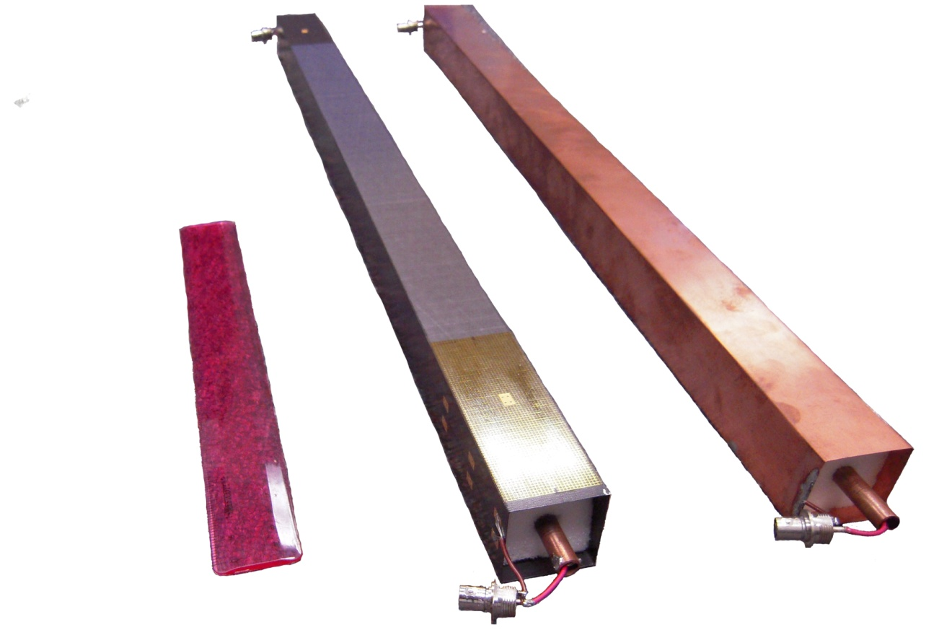
Figure 1. Carbon fiber (center) and all-copper transmission lines.

Test Details:

An HP3468B Multimeter was used to make a 4-wire measurement of the end-to-end resistance of the shields of both transmission lines. To reference the measurement, we shorted the ends of the test leads to the same end of one of the fixtures we made to allow connection to the transmission lines.

Using 2-dimensional finite element analysis software, we computed the characteristic capacitance and inductance for an all-copper, square-shield, air dielectric, round center conductor transmission line with dimensions of those of our samples. With the two values, we computed the characteristic impedance for the transmission. We used the TDR to measure the characteristic impedance for both transmissions lines.

As the characteristic impedance of the transmission lines was not equal to the nominal 50Ω of our test equipment, we constructed a set of resistive matching networks to minimize test measurement error. Note that the measured impedance of both transmission lines were sufficiently close to one another that we made only one pair of matching networks.

With matching networks at each end of the all-copper transmission line, we swept the Agilent 4395A Network Analyzer over a frequency range from 10Hz to 500MHz. We calibrated the analyzer in this configuration considering the all-copper transmission line as a short. The frequency response after calibration was essentially flat across the frequency range. Without changing any of the settings or matching networks we disconnected the all-copper transmission line and replaced it with the carbon fiber shielded transmission line and let the network analyzer sweep over the same range.

Test Results:

End-to-end resistance:

Our initial 4-wire measurement of the resistance of the square copper shield resulted in a value of ~8m Ω. The measurement of the resistance of our fixtures resulted in a similar value, suggesting that their resistance dominated the measurement. Using the resistivity of copper (ρ = 17 x 10⁻⁹ Ω•m) one can compute the expected resistance of the square copper tube at ~ 0.3mΩ.

Our 4-wire measurement of the resistance of the square carbon fiber shield resulted in a value of ~76m Ω (after subtracting the resistance of the test fixtures). Knowing the cross-sectional area and length of the square carbon fiber tube, one can estimate the effective resistivity of the carbon fiber structure at; ρ_{eff} = 4.7 x 10⁻⁶ Ω•m. This value is ~280 times that for copper.

Characteristic Impedance:

The finite element analysis prediction for characteristic impedance of an all-copper transmission line of these dimensions was 89.2 Ω. The measured value of characteristic impedance for both the carbon fiber and all-copper transmission lines was 89 Ω.

Frequency Response:

The all-copper square transmission line was connected to the Network Analyzer using standard RG58 coaxial cables and BNC connectors. Power was delivered to one end of the transmission line and sampled at the other over a frequency range of 10Hz to 500MHz. The Network Analyzer was calibrated using the response of the system (cables, connectors and all-copper square transmission line) so that the displayed resulting response (after calibration) was flat. The all-copper transmission line was then replaced with the carbon fiber transmission line and the response saved.

The after-calibration response of the system including the all-copper transmission line is shown in Figure 2. The response of the carbon fiber transmission line is shown in Figure 3. Anomalies observed in the low frequency range of the carbon fiber transmission line response plot resulted in a re-calibration of the Network Analyzer with the all-copper transmission line at only low frequencies to investigate. (Noise in the low frequency range of the plot was subsequently associated with overloading the network analyzer’s input while characterizing the all-copper shield which looks like a short to the Network Analyzer.) Increasing the attenuation of this input resolved the noisy response. The response of the carbon fiber transmission line at low frequencies is shown in Figure 3. In each case, the upper of the two plots in a figure is the magnitude of the response while the lower is the phase. The frequency axis for the plots in Figures 2 and 3 is logarithmic while it’s linear for the plots in Figure 4.

Figure 2. Response of all-copper transmission line after calibration.

Figure 3. Relative response of carbon fiber transmission line.

Figure 4. Low frequency relative response of carbon fiber transmission line.

Conclusions:

The difference between the computed effective resistivity of the carbon fiber structure and the theoretical resistivity of a similar copper structure is significant. The measured impedance of the two transmission lines is strikingly similar and consistent with our predicted value for an all-copper transmission line. Taken together, the two statements seem at odds with each other. Our predicted value of characteristic impedance uses only the values of capacitance and inductance (per unit length) we obtain from the finite element analysis program that we used. We ignored the conductance and resistance values one finds in a complete description of the components of characteristic impedance because one, the terms tend to be insignificant (compared to the reactive terms) for common transmission line geometries and two, doing so allows us to ignore the signal frequency at which the impedance is computed. When we use a value of resistivity greater than that of copper for the shield in our finite element analysis of the square transmission line, the characteristic per unit length value for capacitance remains the same, but the inductance value decreases, as does the predicted value of characteristic impedance. We suspect that the difference between the lower predicted impedance and the higher measured impedance is made up by the ignored resistance term which is likely to be significant. Further investigation into this inconsistency is on-going.

The comparative measurement of the frequency response of the carbon fiber transmission line to the all-copper transmission line reveals, at frequencies between 10Hz and approximately 78MHz, a difference of less than 0.2dB. At frequencies above 78MHz to the upper end of the range that the Network Analyzer can display (500MHz), the maximum measured difference is 1.5dB, with the carbon fiber structure response more lossy.

The fraction of carbon fiber structure in contact with copper on the flexible printed circuits is less (7% vs. 30%) than the value for the similarly constructed structure used for supporting D0 RunIIb Layer 0 sensors ^{[2]}. The flexible printed circuits for the Layer 0 structure nearly completely cover the area of the carbon fiber structure. The positive results of this investigation with reduced copper contact area are encouraging as we look to minimize the effects of copper mass in regions where it’s unwanted.

References:

[1] W. Cooper, et al,. Nucl. Instr. & Meth. A550 (2005) 127

[2] R. Angstadt, et al,. Nucl. Instr. & Meth. A662 (2010) 298

