

**PPD / EED / Infrastructure Group**

Technical Note: IG_ 20110006

Michael S. Matulik

14-Dec-2011

Revisions

17-Jan-2018

**Procedure for Testing MINoS Master or Minder**

**Wiener Power Supply Units**

**Overview:**

Power for MINoS Master and Minder crates is provided by two different Wiener power units. This document provides a step-by-step procedure for testing either type using an electronic Load Test Stand.

The power units are in the Wiener PL500 series. These custom configured units consist of multiple internal power supplies with a common control interface. The outputs for Master and Minder power units are similar, but not identical. The procedures for testing Master and Minder power supply units are nearly the same, details used in configuring the tests are listed separately to facilitate testing.

The programmable settings for the power units as received are recorded and saved to a test document – one per each power unit / date tested. The settings are changed to be compatible with “full load” testing to stress the power unit. The no-load voltages are recorded for all outputs. The electronic loads are programmed to draw the desired current and the power unit is turned on. A full load test is run for 15 minutes. The display of operating parameters during this test is saved. The load test stand configuration is changed to draw a more operationally representative load from the power unit and the test runs for an additional 45 minutes. The display of operating parameters during this test is saved. The Wiener settings are changed to the default settings (agreed to by MINoS management) for the power unit being tested. The settings after testing are saved. The ability of the power unit to respond to over-current conditions is verified. The ability of the power unit to respond to CANBus commands is verified to complete the test.

An example of a test document is included in the Appendix as a reference.

**Load Test Stand**:

The Electronic Load Test Stand located in room 309 of the D0 Assembly Building utilizes the Chroma 63100 series of modular DC electronic load units. In general, these devices are connected to a source of DC power and operated to draw current from the DC power supply in one of several modes. Testing MINoS Master and Minder requires that the Chroma load modules are placed in the Constant Resistance Low (CRL) mode. The value of the resistance is set by load module and by test sequence as appropriate. Adjustments to the load modules are done manually.

An array of Chroma load modules is inserted into a crate. Inputs to the various load modules are connected to a patch panel to facilitate configuration changes. Changes to the settings for any given module in the crate are made via the crate controller. Figure 1 shows an example of two of the two different modules used in the Load Test Stand. The other type of module has a single input channel, is capable of sinking more power and larger in size. The operation of the two types of modules is the same. Basic operation is described below:

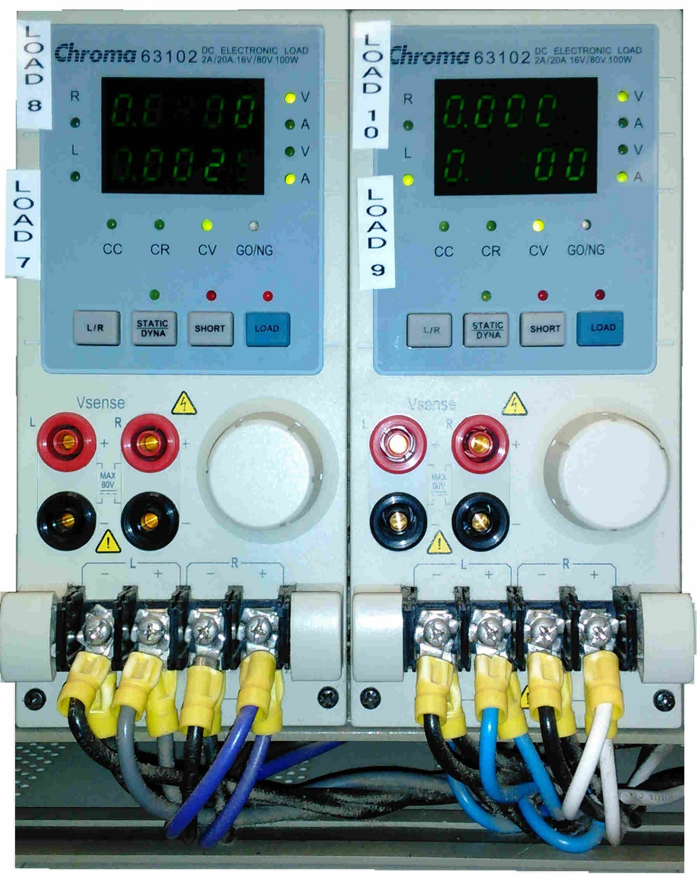

Figure 1. Chroma Electronic Load Modules

* The load modules shown in Figure 1 have two input channels that are operated / controlled independently. The L/R button selects either the left, right or both channel(s). LEDs on the module indicate which load(s) the values in the display correspond to.
  + V or A LEDs indicated whether the displayed value indicates volts or amps.
  + The LOAD button must be pressed, and the corresponding LED active, to enable the module and allow it to sink current.
  + Small changes in the resistance (necessary to verify the operation of the power unit to respond to current trip limits) can be affected by rotating the front-panel dial.
* The interface on the single-channel load module is similar, but lacks the L / R button.

Figure 2 shows the front panel of a Crate Controller for a Chroma crate. Changes to the configuration of any modules inserted into the crate are made via the controller. Basic operation is described below.

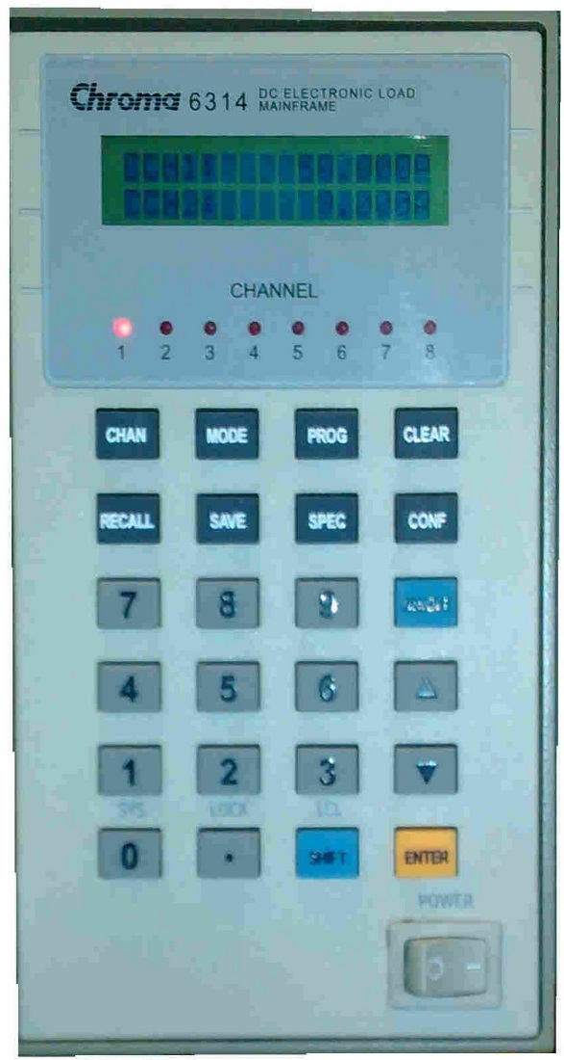

Figure 2. Chroma Crate Controller.

* One channel number indication on the front panel of the Controller is associated with one Chroma Module inserted into the crate. Channel 1 addresses the left-most module. Pressing the CHAN button steps through the installed modules, incrementing left to right. Note that higher power modules require 2 crate slots so that pressing the CHAN button once a higher power module is addressed will result in a two-channel skip in the addressed channel.
* With the desired module addressed, press the MODE button.
* Repeatedly press either the up or down arrows until the CRL mode is displayed. Press the ENTER button to access the CRL sub-menu.
  + If two lines are shown in the display, press the up or down arrow buttons until the upper line is active.
  + Using the keypad, enter the desired load resistance and press enter.

Figure 3 shows a portion of the patch panel used to make convenient connections to Chroma load modules.

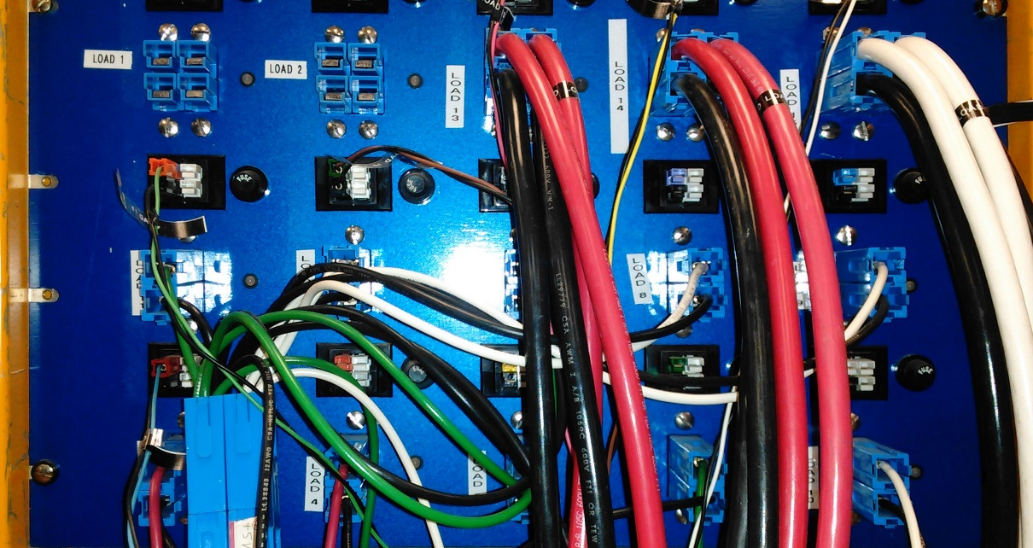

Figure 3. Load Test Stand Connection Patch Panel

* The larger current-carrying Andersen PowerPole connectors are wired directly to the input terminals of Chroma load modules. Labels on the front panel can be matched with labels on the load modules. Connections from the power supply being tested are made with wire and mating connectors.
  + Chroma load modules are polarity sensitive, the upper connector(s) should be connected to the positive output of the power supply under test.
* Smaller PowerPole connectors located directly above the current carrying connectors for each load can be used for remote sense connections.
  + The left-most pair of connectors are used for sense lead conections.
  + The right-most pair of connectors are unused.
  + Like the current carrying connectors, the positive sense lead connection is to the upper connector.
  + The positive sense lead connection protected with an adjacent panel-mounted fuse (1A).
* This document contains wiring diagrams for making connections from either a Master or Minder power unit to the Load Test Stand patch panel, including sense lead connections.

**UEP6000**:

Wiener supplies a program for communicating with power units in the PL500 series (as well as others) via an RS232 connection. A non-standard RS232 cable, built to Wiener specifications, is available in the carrying case that houses the Dell laptop (FNAL tag number: 100572) currently used for this purpose.

* A valid user name is: LoadTestStand
* A valid password is: 0ITestEm1!
* One location for the file is:
  + C:\WINDOWS

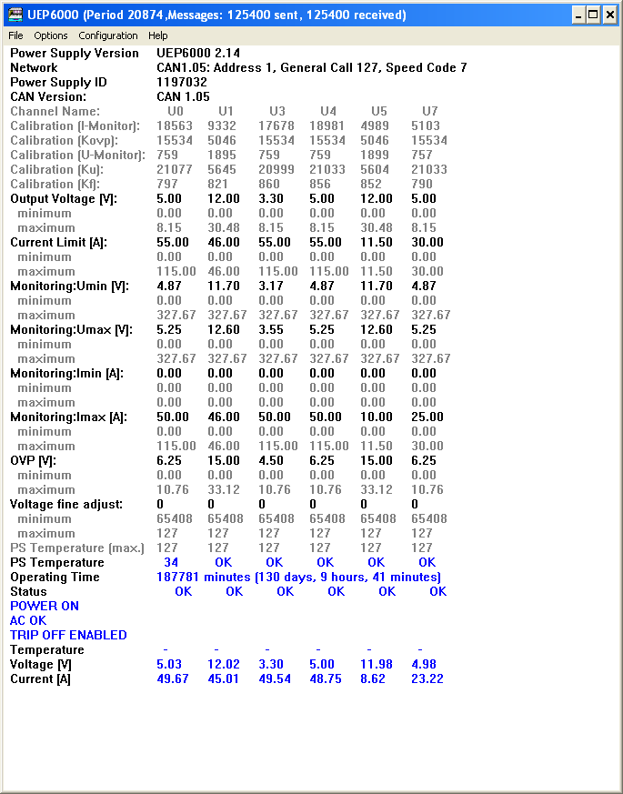

Figure 4. UEP6000 Interface on Windows Computer

A typical UEP6000 interface to a PL500 series Wiener power unit is shown in Figure 4. The power supply ID / serial number is indicated. CANBus settings are indicated. In general, the user can manipulate the voltages / currents indicated in bold font. Clicking on one of these fields will bring up a dialog box where new values can be entered. The number of power supplies in the power unit is different for Master and Minder supplies. The user can select which supplies are displayed using the Configuration pulldown. Note that some power units have been programmed with more descriptive supply names instead of numbers. The horizontal position of the information is the same.

* A MINoS Master supply has 4 outputs:
  + U0: 5V / 230A
  + U1: 12V / 46A
  + U3: 3.3V / 115A
  + U5: 12V / 46A
* A MINoS Minder supply has 6 outputs:
  + U0: 5V / 1115A
  + U1: 12V / 46A
  + U3: 3.3V / 115A
  + U4: 5V / 115A
  + U5: 12V / 11.5A
  + U7: 5V / 30A

The user can click on the POWER OFF or POWER ON field to turn on or turn off the supply respectively.

**PCAN-Wiener**:

Wiener supplies a program for communicating with power units in the PL500 series (as well as others) via a CANBus connection. The Dell Latitude D6540 laptop (FNAL Tag number 126698) has the PCAN-Wiener program installed. A USB to CANBus interface is attached to a cable. This cable is connected to a 9-pin SubD connector on the back plane in the Wiener chassis. Connect the USB interface to the computer before starting the PCAN- Wiener program.

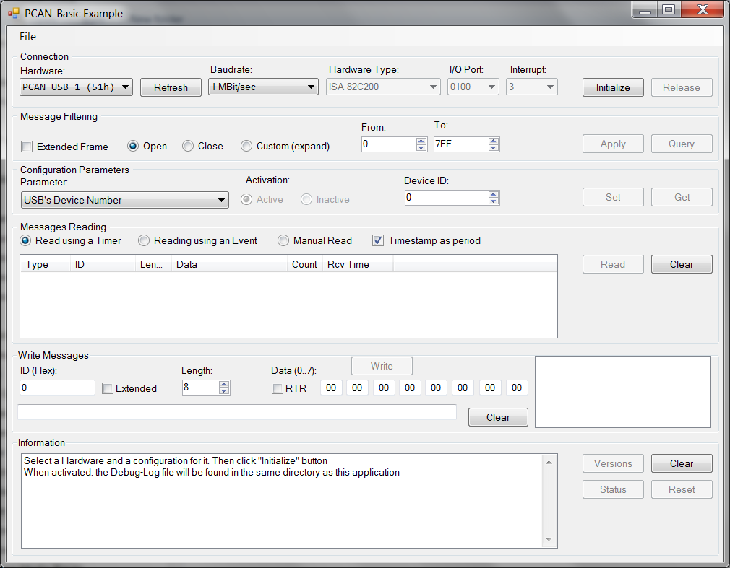

Figure 5. CANBus Interface

The interface for the PCAN-Wiener program is shown in Figure 5. CANBus compliance consists of the ability to place a request for information from the power unit and to see the power unit respond. Successful attempts to turn the power unit, then back off complete the test.

Areas of specific interest in the interface are:

* The Baudrate field in the top line.
* The Device ID field in the third line.
* The Messages Reading pane.
* The Write Messages section.

**General Power Supply Testing Procedure**:

* A MINOS Master or Minder Wiener power unit is inserted into the Wiener crate fastened to the bench adjacent to the Load Test Stand.
* Connections to the Load Test Stand, as described in the appropriate MINoS power unit test detail section found below are made / verified.
* Verify all Chroma load module loads are not enabled.
* A computer with the Wiener PCAN-Wiener program installed and a USB-CANBus adapter is used to communicate with the power unit to verify CANBus compliance. Operate the power unit from within the PCAN-Basic window:
  + Verify Baud Rate = 1Mbit/sec.
    - Press the “Initialize” button.
  + Set “Device #” to 1
    - Press the “Set” button.
  + In the “Write Messages” block:
    - Set the “ID(Hex)” field to 7F
  + Check the “RTR” checkbox.
  + Press the “Write” button
    - Verify that something appears in the “Message Reading” block.
  + Set the “ID(Hex) field to FF
  + Uncheck the “RTR” checkbox.
  + Set the Most Significant Byte field to 03
  + Press the “Write” button
    - Power unit should turn on.
  + Set the Most Significant Byte field to 01
  + Press the “Write” button
    - Power unit should turn off.
  + A power unit successfully completing all these steps is deemed to be CANBus compliant. Note the success / failure as the testing document has a field for this information.
    - It is possible that a CANBus failure might be linked to an incorrect speed code setting in the power unit. The desired code is 1. This can be accessed / changed using the UEP6000 program.
* A computer with the Wiener UEP6000 program installed and an RS 232 connection is used to operate the power unit and capture operational information. The RS232 cable connects to the SubD connector on the power unit. The AC power cord is connected to the power unit. Open the UEP6000 executable with the power unit powered.
* The appropriate template (Master / Minder) file is opened in Word. The laptop used at the time this not is written is old and can no longer be connected to the Fermilab network.
  + Template files are found on the laptop:
    - C:\Data\Load_Test_Stand_Results
  + The file is saved as a Word document (.docx) using the 7-digit power unit serial number as the first portion of the file name followed by the test date (yyyymmdd) separated by an underscore.
    - e.g. 1197032_20121115.docx.. Files are saved to the same subdirectory that the template files are found.
  + Scroll to the last page in the word document; fill in the Tested By, Serial Number and Date fields. Save the document periodically during the test.
* Set the MODE for all load modules to CRL.
* Set the resistance value for each module to the Full Load Test value as described in the appropriate MINoS power unit test detail section found below.
* A typical UEP6000 interface will be displayed on the computer screen for a properly operating power unit.
* Save the settings found in the power unit as received by capturing the active UEP6000 display by pressing the Ctrl, Alt and PrtScn buttons simultaneously.
* Paste the image saved to the clipboard into the Word document by clicking onto the first page, above the caption for Figure 1, and pressing the Ctrl and v keys simultaneously.
* Change the voltage and current fields in the UEP6000 interface to the values found in the Full Load Test section as described in the appropriate MINoS power unit test detail section found below.
* Press the POWER OFF field in the UEP6000 interface to turn the power unit on.
* Observe the voltage readings found on the front panels of all of the load modules used in the test and record these values into the appropriate cells in the No Load column found in the chart found on the last page of the Word document.
* Turn off the power unit by clicking on the POWER ON field.
* Manually enable all the load modules used in the test.
* Turn on the power unit by clicking on the POWER OFF field. Note the time of day.
* Observe the voltage readings found on the front panels of all of the load modules used in the test and record these values into the appropriate cells in the Full Loading columns found in the chart found on the last page of the Word document.
* Save the settings found in the power unit in this porting of the test by capturing the active UEP6000 display by pressing the Ctrl, Alt and PrtScn buttons simultaneously.
* Paste the image saved to the clipboard into the Word document by clicking onto the second page, above the caption for Figure 2, and pressing the Ctrl and v keys simultaneously.
* After 15 minutes, manually change the resistances for all Chroma load modules used in the test to the values found in the Nominal Load Test section as described in the appropriate MINoS power unit test detail section found below.
* Observe the voltage readings found on the front panels of all of the load modules used in the test and record these values into the appropriate cells in the Nominal Loading columns found in the chart found on the last page of the Word document.
* Save the settings found in the power unit in this porting of the test by capturing the active UEP6000 display by pressing the Ctrl, Alt and PrtScn buttons simultaneously.
* Paste the image saved to the clipboard into the Word document by clicking onto the third page, above the caption for Figure 3, and pressing the Ctrl and v keys simultaneously.
* Press the POWER ON field to turn off the power unit.
* Change the voltage and current fields in the UEP6000 interface to the values found in the Post Test section as described in the appropriate MINoS power unit test detail section found below.
* Set the resistance value for each module to the Post Test value as described in the appropriate MINoS power unit test detail section found below.
* Press the POWER OFF field to turn the power unit on.
* Save the settings found in the power unit in this porting of the test by capturing the active UEP6000 display by pressing the Ctrl, Alt and PrtScn buttons simultaneously.
* Paste the image saved to the clipboard into the Word document by clicking onto the fourth page, above the caption for Figure 4, and pressing the Ctrl and v keys simultaneously.
* Press the TRIP OFF ENABLED field to disable the ability of the power unit to turn off if any of it’s internal power supplies experiences a trip condition.
* Manually decrease the resistance of a Chroma load module associated with each power unit output. Observer the increasing current on the UEP6000 display. At or above the value equal to the trip current value, the color of the current display should change to red. This is the indication that the trip limit has been met and that the power unit recognizes the condition. Manually increase the resistance to a value that results in a current value less than the trip value. Repeat for all power unit outputs.
* Press the TRIP OFF DISABLED field to re-enable the ability of the power unit to turn off if any of it’s internal power supplies experience a trip condition.
* Note the results of the Current Trip Test in the appropriate field on the last page of the test document.
* Note the results of the CANBus compliance test in the appropriate field on the last page of the test document.
* Add any comments to the Test comments field on the last page of the test document. Possible entries might include:
  + Using compressed air to blow out accumulated dust.
  + Lubricating chassis jack-screws with anti-seize.
  + Highlighting test results that render the power unit failed.
* Save the test document.
* As the laptop that has the UEP6000 program installed cannot be connected to the Fermilab network, completed test documents need to be manually transferred to the following location:
  + \\ppdserver\eed.ppd\Project\Infrastructure\MINoS\Load_Test_Stand_Results

**MINoS Master Wiener Power Unit Test Configuration**:

Wire connections from Wiener chassis backplane to Load Patch Panel:



Wiener Power Unit Configuration for Load Testing:



Wiener Power Unit Configuration for Post-Load Testing:



Chroma Load Resistance Settings (CRL mode):



**MINoS Minder Wiener Power Unit Test Configuration**:

Wire connections from Wiener chassis backplane to Load Patch Panel:



Wiener Power Unit Configuration for Load Testing:



Wiener Power Unit Configuration for Post-Load Testing:



Chroma Load Resistance Settings (CRL mode):



Revision History:

17-Jan-2018

Completion of document.

Appendix:

Copy of completed test document: