PPD / EED / Infrastructure Group
Technical Note: IG_ 20130001
Michael S. Matulik
24-Apr-13

Procedure for Connecting NOvA Cooling System to Rack Protection / Interlock Interface Chassis Interlock Interrupt Input

Overview:

Each NOvA Low Voltage, High Voltage and Network rack has a Rack Protection / Interlock Interface Chassis installed. The purpose of this chassis is to generate an Interlock Signal (24Vdc) that Power Distribution Chassis, also located in each rack, use to know when to allow AC power to pass. To allow NOvA personnel to remotely turn off power to a given rack, the RP / II Chassis has a Normally Closed reed relay placed in series with the Interlock Signal. Supplying the coil contacts of this relay with ~ 10mA causes the relay contact to open, interrupting the Interlock Signal, causing AC power in the rack to drop.

The NOvA Cooling System is the source of the current required to interrupt the Interlock Signal in any given rack. This document will detail the procedure of connecting the Cooling System to the RP / II Chassis already installed at Ash River. Connections to the Cooling System are detailed in a separate document.

The active output from the Cooling System is a 24Vdc level. To ensure that the coil contacts on the relay see an appropriate current, a 2kΩ 1/2W resistor needs to be placed in series with the 500Ω resistance of the coil. A schematic / wiring diagram for the proper connections can be found in the Appendix.

Additional Definitions:

- 3-conductor cable: Jacketed 3-conductor (22AWG) cable with shield and drain wire. For each affected rack, this cable starts at the Cooling system and terminates at the Panel in the rack.
- Cable Breakout: The National Instruments 37-conductor Cable Breakout Card containing four 10-position screw terminals.
- NI-cRIO: National Instruments compact RIO backplane populated with RTD as well as Analog and / or Digital I/O modules. One such backplane is installed in each NOvA High Voltage Rack.
- Panel: A Rack Monitor Panel consisting of a National Instruments 37-conductor Cable Breakout Card, an airflow / temperature sensor, small plug-in power supply and associated cables.
- Terminal Strip: One of four 10-position screw terminals installed on the National Instruments Cable Breakout Card.

Panel Wiring Modification Procedure:

- At each Panel, disconnect the yellow / violet insulated wires from the Terminal Strip associated with positions 26 and 7 on the Cable Breakout. See Figure 1 for a representative picture.

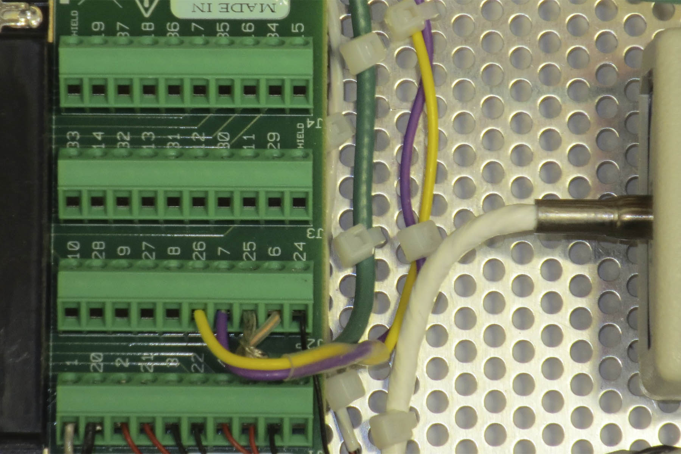
Figure 1. Expected Interlock Interrupt connections in Panel.

- Move the ends of the yellow and violet insulated wires to the Terminal Strip associated with positions 15 through 19 (and 34 through 37). Insert, but don’t tighten, the yellow and violet insulated wires into positions 35 and 16 (respectively). Note that a wire tie providing strain relief may need to be removed.
- At each rack, remove jacket from the 3-conductor cable exposing ~ 2 inches of conductors, shield and drain wire. Completely trim the white insulated conductor as well as the shield and drain wire back to the jacket.
- Strip ~1/4 inch of the insulation from both the black and the red insulated conductors. Insert the end of black insulated conductor into Terminal Strip position 16 (along with the violet insulated wire) on the Cable Breakout. Insert the end of the red insulated conductor into Terminal Strip position 37.
- Insert the ends of the pre-formed 2kΩ ½W resistor into Terminal Strip positions 37 and 35, mating with the red insulated conductor and yellow insulated wire already installed.
- Verify the installation matches the representative picture found in Figure 2. Tighten the screws for Terminal Strip positions 16, 35 and 37 to secure the connections.

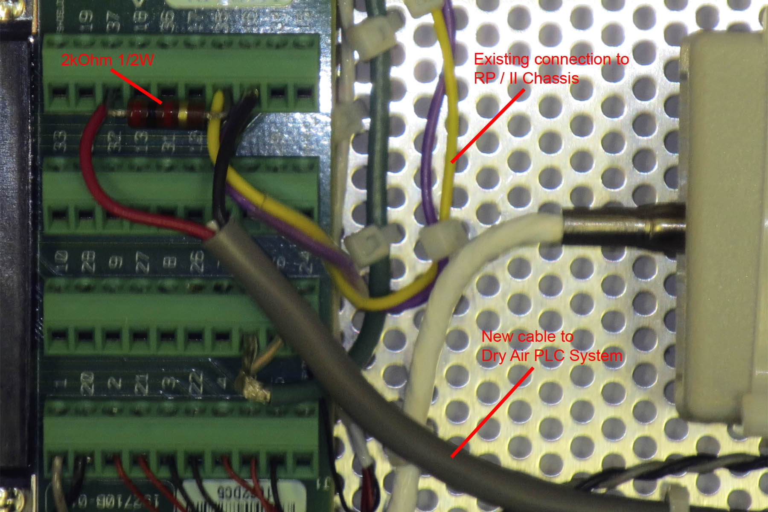
Figure 2. Modified connections for operating Interlock Interrupt.

Verification and Troubleshooting:

The proper operation of the reed relay in each RP / II Chassis was verified prior to shipping. The connection of the yellow / violet insulated wires to the Twin-BNC cable connector already mated to the Twin-BNC connector mounted on the Chassis is assumed to be correct. Making the connections described above should not result in the loss of AC power to the rack as long as the output of the Cooling / PLC system is not active. Once connected one would need to activate the particular output of the Cooling System associated with a particular rack and verify that the AC power in that specific rack is dropped. If the rack is not populated, one can use the AC indicators on the Power Distribution Chassis to verify the operation of the relay. Note that the Interlock LED located on the RP / II Chassis will remain illuminated as long as the smoke detector is not in alarm and will remain illuminated even after the relay opens.

If power in the rack doesn’t drop, verify that the red insulated conductor is about +24Vdc with respect to the black insulated conductor of the 3-conductor cable at the Panel. If 24Vdc is not present; verify that this particular cable is connected to the active output of the Cooling System. Verify the proper connections of wires, conductors and resistor on the Terminal Strip, adjust connections as necessary. Verify that the voltage on the yellow insulated wire is ~ +5Vdc with respect to both the black insulated conductor and the violet insulated wire.

Appendix:

Drawing 173876: NOvA Far Detector Control System Interlock Interrupt Schematic / Wiring Diagram.

