PPD / EED / Infrastructure Group
Technical Note: IG_ 20140002
Michael S. Matulik
17-Apr-2014

G-2 Straw Tube Readout
Flexible Printed Circuit
Feasibility Investigation

Overview:

Straw tubes for the G-2 Experiment are arranged in three offset rows of 32. A flexible printed circuit is being considered to be able to supply high voltage to the center conductor of each tube and provide a readout path back to amplifiers located outside the volume of the gas manifold. The design of the flexible printed circuit is relatively straight forward, except for the area in the closely spaced tubes.

Conceptually, the finished circuit is envisioned to be roughly rectangular, approximately 300mm long and 65mm wide. One end of one of the long edges is envisioned to be comb-like to allow connections to the center contacts of the tubes. The layout of the tubes puts severe restrictions on the width and spacing of the “teeth” of this comb-like structure. Additionally, the offset pattern of the tubes don’t permit all of the “teeth” to be straight.

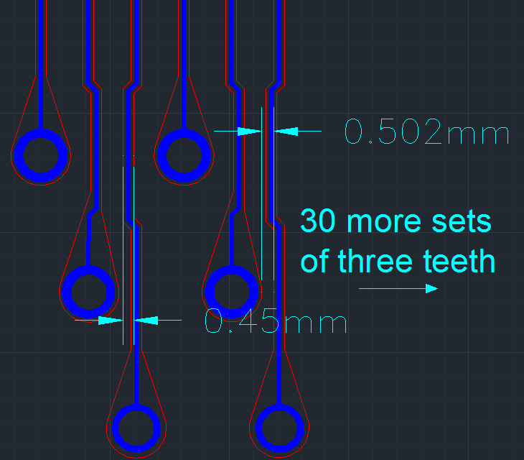
Figure 1. Initial approximation of comb details.

Figure 1 shows the initial thoughts for the structure of the teeth in the comb-like structure of the flexible printed circuit used for straw tube readout. Out of necessity, the teeth are narrow and close together with an inverse relationship between the two characteristics. The dimensions shown in Figure 1 are a starting point. We are interested in learning about the details for laser-routing these fingers from a flexible printed circuit.

Circuit Information:

At this point, we believe that the circuit would be a 3-copper layer circuit with upper and lower flexible solder mask layers. The thicknesses of the polyimide cores has not yet been determined, and might be adjusted if doing so has a positive effect on the ability to reliably realize all 96 teeth. It’s also possible that these teeth could extend on a single copper layer / single core to facilitate the routing process. Note that there will be additional “tabs” that protrude from the circuit to make ground connections to the manifold itself. The size / location of these tabs has not yet been decided, but are not thought to play a role in the ability to route these circuits.

Request for Comments:

Please consider the information presented in this note. We are interested in learning the likelihood that such a fine structure can be realized in a flexible printed circuit. Specifically, we are looking to learn the minimum distance between any two sections of adjacent teeth that can be reliably reproduced and the corresponding minimum width for a “tooth”. The spot size of the laser would be an interesting bit of information as well.

Contact Information:

Questions / comments can be directed to:
Michael S. Matulik
Fermi National Accelerator Laboratory
MS 222
Kirk & Wilson Roads
Batavia, IL 60510
630-840-4091
matulik@fnal.gov

