PPD / EED / Infrastructure Group
Technical Note: IG_ 20140006
Michael S. Matulik
29-Oct-2014

Thoughts on Noise Pick Up in U.S. CMS FPix Modules Assembled to Graphite / Carbon Fiber Support Structures

Overview:

The geometry of the assembly is depicted in Figure 1.

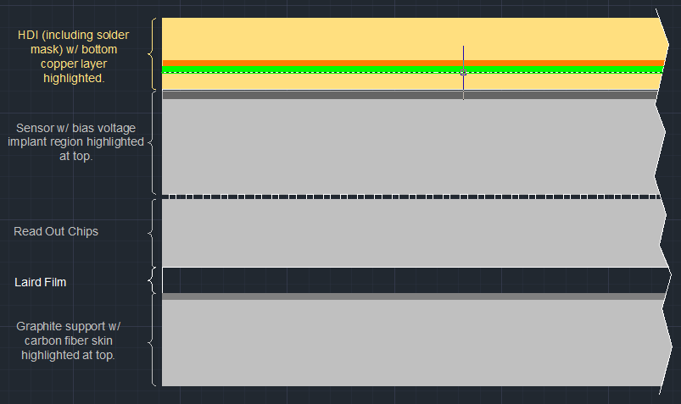
Figure 1. U.S. CMS FPix Module Assembly Stack Up.

The interesting portion of the HDI is from the bottom copper layer (primarily at ground potential) down; through the solder mask and the polyimide cover coat.

The HDI is laminated to the top of the sensor with a thin layer (estimated to be 5um) of adhesive. The uppermost layer of the sensor is an implant region that will be at the applied sensor bias voltage. The area of this region is nearly the area of the sensor itself. The estimated thickness of the sensor is 300µm.

The sensor is bump-bonded to the Read Out Chips, which are in turn laminated to the graphite / carbon fiber support structure (blade) with a 76um thick layer of thermally conductive, electrically resistive film by Laird. Bump height is estimated to be 15µm. The estimated thickness of the Read Out Chip is 200µm.

Previous studies [1] have shown that carbon fiber is capable of propagating ac current across it’s surface and will readily act as an electrode in a parallel plate capacitor, functioning nearly as well as a solid plane of copper.

Pursuant to discussions initiated by Stefan, I believe the argument can be made that the carbon fiber on the graphite support structure is capacitively coupled to the ground plane in the HDI. Knowing the thicknesses and dielectric constants of the various materials contained in this capacitor, as well as the area of the plates (set by the area of the HDI), one can compute the value of this capacitor as the series sum of the capacitors formed by the various dielectrics. The estimate of value of this capacitance is 0.13nF.

If the (ac) potential of the surface of the carbon fiber skin of the blade is different from that of the HDI ground plane, current will flow through this capacitor in accordance to it’s impedance (imagined to be primarily capacitive reactance). The flow of this current will be through all of the materials found between the HDI and the carbon fiber. Of primary concern are the sensor and the Read Out Chips.

The uppermost region of the sensor can be considered to be a conductive layer that will be biased to some voltage when the sensor is operating. Further, it’s my understanding that this conductive region is capacitively coupled to all of the individual pixels through the bulk silicon. I suspect that unwanted signals introduced into the conductive region of the sensor could be coupled into the pixels through this arrangement, though the details of the design of the pixel detector may mitigate this concern.

Common methods used to direct unwanted signals from a conductive region involve providing a low impedance path to the current return path (ground) to the source of the unwanted signals. As the sensor needs to be biased to work, a direct connection to ground isn’t feasible in this assembly. Often a physical capacitor is added to provide this path. Such a bypass capacitor is not present on the HDI: It’s my understanding that the concern over the possibility that a very energetic particle passing through the sensor could generate a low resistance path for the charge stored on this bypass capacitor to discharge directly into the pixel and it’s dc-coupled amplifier on a Read Out Chip (resulting in damage to the pixel / amplifier) is the primary reason for the lack of a bias voltage bypass capacitor.

It should be noted that the conductive region of the sensor and the bottom copper layer of the HDI form a parallel plate capacitor as well. The estimated value of this capacitor is 0.47nF.

The wedge shaped blade consists of a graphite core with carbon fiber skins on either face. Some number of blades are inserted between two graphite / carbon fiber strips formed into semi-circles to form a half-disk. For outer half-disks, there are 17 blades, for inner half-disks there are 11. Modules are laminated to both faces of each blade. It’s my understanding that the interface between all blades and the two strips that form the half-disk is contact and epoxy. Resistance (dc) measurements made by Stefan on assembled half-disks suggest, but do not ensure, that the entire structure is electrically connected between all of it’s components. Given the nature of the interface between the blades and the graphite / carbon fiber strips it would not be wise to assume that the entire structure will be at the same electrical potential at all times.

Embedded in the graphite / carbon fiber ring structure are stainless steel tubes through which will flow CO₂ used to cool the electronics on the blades. Stefan’s measurements indicate that the stainless steel tubes are also electrically connected to the half-disk structure, but as stainless steel is not a great conductor, this connection isn’t great either. These stainless steel tubes originate outside of the volume occupied by the FPix Service Cylinder. As such their potential contribution to noise pick-up on the half-disk structure needs to be considered regardless of the relative quality of the measured electrical connection. Of particular concern would be current flowing along the length of the tubes magnetically coupling to and inducing currents into the half-disk structure components.

The carbon fiber Service Cylinder is to be fabricated with a thin flexible printed circuit co-formed to it’s inner surface. This flexible printed circuit performs two functions; it provides the ability to force the carbon fiber of the service cylinder to a known potential (ground) and to be able to connect various devices / structures within it’s volume to the same potential. It’s imagined that the Service Cylinder half-cylinders will be electrically connected with their associated End Flange structure.

Noise Pick Up Mitigation:

Though tests for noise susceptibility on individual components comprising the FPix detector at CMS can be imagined, and should be performed to determine susceptibility, certain steps can be taken to minimize the probability that these components are subject to environments where noise sources are present.

Stainless Steel Cooling Tubes:

Stainless steel cooling tubes pass through the End Flange structures located at each end of the volume occupied by the pixel detectors. It is assumed that the two FPix detector systems on either side of the BPix detector are electrically isolated from each other and the BPix detector. The End Flange structures define the detector ground for the FPix detector. It is believed that the equivalent of our safety (earth) ground is connected to each of the two End Flange structures.

As conductors, the cooling tubes provide paths for carrying unwanted signals into the pixel detector volume. The current design has the cooling tubes electrically isolated from the End Flanges (assumed to be metallic), using an insulating sleeve to prevent contact. There should be an electrical connection from all cooling tubes passing through the End Flange structures to the End Flange to divert noise to detector ground. Depending on the frequency sensitivity of the pixel detector / amplifier combination, this connection could be capacitive. Once inside the volume defined by the End Flange, the stainless steel tubes provide cooling for the dc-dc Converters that provide power to the components on the HDI. Current understanding of the design of the dc-dc Converter Board suggests that a thermally conductive / electrically insulating film is used to connect to the cooling tubes. It is unlikely that the thermal structure to which the dc-dc Converter Board is assembled will be in contact with both source and return cooling tubes. The cooling tubes pass the Port Card but while they are not in direct contact with it, it’s likely that the thermal support for the Transmitter Optical Sub Assembly (which is in contact with the Port Card ground net) will be. It is unlikely that the thermal support will contact both the source and return cooling tubes.

After passing the Port Card, the cooling tubes loop through each of the upper graphite / carbon fiber strips that support the blades in both inner and outer half-disks. For each, the cooling tubes enter and leave at the mid-point of the strip, spanning the half-length in one direction, looping back (again within the graphite / carbon fiber strip, traveling the entire length of the strip before looping back again to exit at the mid-point. Current traversing this loop has the potential to magnetively couple into the upper graphite / carbon fiber strip, which may set up potential different than that of the lower strip. Should these two surfaces be at different potentials currents would flow across the carbon fiber surfaces of the blades. As the surfaces of the blades are closely coupled to the bottom copper layer of the HDI the potential to couple unwanted signals into the sensor exists.

To help alleviate the potential of magnetively coupling into the upper strip structure, the supply and return tubes should be electrically shorted to one another at the point they enter the strip structure. To minimize the thermal short at this point, this electrical connection could be made with a number of small gauge wires.

Electrical Grounding Using the HDI:

Ensuring that the potential of the carbon fiber skin of the blade is the same as the potential of the ground plane of the HDI would ensure that unwanted signals would not couple into the sensor and / or Read Out Chips located between. The current design of the HDI does not provide any location one might imaging using to make this connection. Doing so would likely involve adding a thin flexible printed circuit to the carbon fiber face of the blade, in a manner similar to what’s done with the service cylinder carbon fiber. This would place a thermally insulating layer in series with the intended heat flow path from the module assembly and is likely to be reject for this reason. In addition, the upper surface of the HDI doesn’t have sufficient room to provide a pad large enough for this purpose.

The area of the blade that is not covered by the module assembly is not insignificant. The uncovered fraction of the blade surface is located to the side of the installed module. In the arrangement of the half-disks, this uncovered area is located in the area overlapped by the blade above – in the area covered by that blade’s module. In this arrangement, only the blade at one end of the half-disk has an uncovered area exposed. Given the location of the half-disk structures in the volume defined by the grounded service cylinder, one can make an argument that coupling unwanted signals to the uncovered and exposed surface of each half-disk is unlikely. The geometry of the half-disk structures would present lower impedance targets to likely sources of unwanted signals than the uncovered and exposed portion of a blade.

The areas and locations of the graphite / carbon fiber strip structures that define a half-disk are such that one would not feel comfortable making a similar argument. One needs to consider the real possibility that the two strips in a half-disk are at different potentials, with currents flowing through all blades, but not equally as the mechanical connections between the blades and the strip doesn’t ensure electrical connection. Currents flowing across the surface of the carbon fiber in the blade would couple into the ground plane of the HDI, through the sensor and Read Out Chips.

One approach that may be investigated for forcing the potentials of the two strips in a half disk to the same, and known, potential would be to make electrical connections to the pads available on the meshed flexible printed circuit on the inner surface of the Service Cylinder. Unfortunately, the radial positions of the strips in a half-disk result in connections that differ in impedance (primarily inductive reactance). The number of connections that one could envision making from the half-disk structures to the Service Cylinder are limited – the inner most strip would need the most connections to reduce impedance, but it has the smallest available area.

The HDI is a flexible printed circuit and as such one can imagine changing the shape to assist in making a grounded connection that should mitigate this concern. The most useful change to the shape of the HDI I can imagine to accomplish electrical grounding is to extend the long edges of the HDI in opposite corners. An example of this geometry can be seen in Figure 2. Note that no details are inferred by this conceptual drawing.

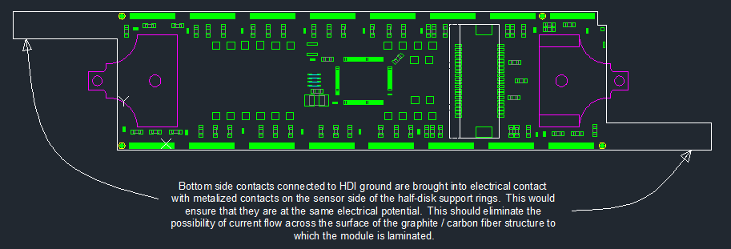
Figure 2. HDI Grounding Extension Concept.

Note that these extensions would need to be narrow enough to pass the module holders. The only metal layer that would exist in these two extensions would be the bottom, the only electrical connection would be ground. The length of these two extensions would be sufficient to contact the graphite / carbon fiber strips that define the half-disk, not to make connection to the blade itself. The premise is that the potential between the upper two graphite / carbon fiber strips that define a half-disk would be minimized by low impedance connections to the HDI ground net.

Were there to be appropriate pads on the strip structures, one could design the bottom-side contacts on the extensions of the HDI to make a robust electrical connection to them. A method for realizing solderable (an ideal case) pads onto graphite has not been determined, which puts this potential solution in a bit of an R&D stage. Given the desire to release the design of the production HDI soon, R&D delay will not be well received. This modification to the HDI layout should be implemented even if the exact method of connection to the graphite / carbon fiber strips has not yet been determined. The nature of flexible printed circuit construction is such that these extensions could easily be removed at a later date if they turned out not to be useful.

Defining Ground:

Three power supply connections are required by components in each module; the two low-voltages (VA+, VD+) required by the TBM and Read Out Chips, and the sensor bias voltage. The source of the two low voltage connections are dc to dc converters found on the DC-DC Converter Boards found in the Service Cylinder. The source of the bias voltage is a CAEN power supply module. To operate properly, any power supply must be connected in a closed circuit – the current drawn by the load(s) needs to return to the supply. The return paths for the three power supplies connected to a module are forced to be common on the HDI. The common net is ground. A given HDI is connected to a connector on a Port Card by an aluminum flexible cable. The common ground net on the HDI is maintained on the aluminum flex cable. The return path for the three supplies is also common on the Port Card. From the Port Card looking back to toward the sources of power, the bias voltage source and it’s return are split from the low-voltage connections and bypasses the dc-dc Converter Board (source of the low-voltage connection). The bias voltage connections are present and filtered on the Filter Board.

VA+ and VD+ are supplied by custom dc-dc converter modules located on the dc-dc Converter Board. The converters draw raw power from CAEN power supply modules through the Filter Board. The common return for the low-voltage connections from the HDI are made common with the return paths back to the CAEN modules on the dc-dc Converter Board – there’s only one ground on the dc-dc Converter Boards.

One can define ground in two ways in the Forward Pixel system; the Detector Ground provided by the connections to the End Flange structures and the most common return path for power supplies in the system. These two are not currently thought to be the same in the Forward Pixel system. The most common return path for power supplies exists on Port Cards. A number of Port Cards are installed in each Service Cylinder half-cylinder. Each Port Card connects to (up to?) 7 HDIs via aluminum flex cables. For sake of discussion, I will assume that all HDIs that connect to a single Port Card may or may not be installed in the same half-disk structure. If the ground nets of all Port Cards are not at the same potential, then the likelihood of current flowing between these ground nets, or their extensions onto HDIs, is increased. The installed locations of the Port Card are convenient for making low impedance connections to the grounded Service Cylinder. The common ground net on each Port Card should be connected to the local Service Cylinder half-cylinder via the solder pads on the flexible printed circuit that line it. Doing so will maximize the likelihood that the ground nets on all HDIs are at the same potential minimizing the likelihood of unwanted signals travelling between these nets.

Recommendations:

Stainless steel cooling tubes should be electrically coupled to the End Flange structures they pass through. This should eliminate unwanted common-mode signals that may be travelling on them.

The stainless steel cooling tubes should be electrically shorted to each other at the point they enter the half-disk structure. Any unwanted currents flowing along the tubes would not be permitted to couple into the half-disk structure with this precaution.

The design of the HDI should be modified to provide two bottom side ground contacts at opposite corners of the circuit. The length of these extensions should match the most likely locations of pads on the graphite / carbon fiber strips that define the half-disk. If the locations of these pads on both inner and outer as well as both left and right hand half-disks would permit one HDI design.

Ensuring that the ground nets of all HDIs installed in a half-disk are at the same potential is a worthwhile goal. This can best be accomplished by connecting the common ground net of each Port Card to the local grounded Service Cylinder half-cylinder.

References

[1] W. Cooper et al., D0 Collaboration, Nucl. Instr. and Meth. A 550 (2005) 127

