PPD / EED / Infrastructure and Support Group
Technical Note: IG_ 20150001
Michael L. Cherry
Michael S. Matulik
1-Jun-15

Linear Coherent Light Source – II
Vessel Demagnetization
Coil Connection Proposal

Overview:

Anthony C. Crawford (Fermilab Technical Division) has successfully demonstrated a method of demagnetizing large cylindrical steel vacuum vessels destined to be used for the LCLS-II project at SLAC. Simply stated, a vessel is to be subjected to magnetic fields of reversing direction and diminishing strength. Coils around the vessel carrying current from a programmable current source will provide the magnetic field. It is envisioned that the vessels will be subjected to this demagnetization process as they are received from the vessel vendor, after the associated cryogenic piping and RF Cryo-modules have been installed and perhaps in situ at SLAC.

It is expected that a current waveform (truncated triangular) with a maximum amplitude of 65A will be run through the coils in both directions. The estimated period of this two-direction cycle is 25 to 30 seconds. The amplitude of the current in subsequent cycles will be reduced by some fraction until some terminal current value is reached. The entire process should take about 30 minutes.

Members of the PPD / Electrical Engineering Department have been asked to develop a process of implementing this method to demagnetize a number of vessels. We see this effort broken into the following tasks: Specification of a programmable current source and associated current distribution equipment. Specification of the current carrying conductor(s) that comprise the coils. Working with Technical Division staff to physically realize the coils. Specification of the method of connecting the coils to each other or to current distribution equipment as appropriate. Realizing the system in a safe manor capable of passing installation inspections at SLAC, Fermilab and Jefferson Laboratory (a parallel vessel assembly site).

This note presents a proposal for a means of making connections to the coils.

Coil Descriptions:

Two type of coils are required. Regularly spaced Helmholtz coils on the outer surface of the vessel connected in series provide for the demagnetization of most of the vessel. A trim coil at each end of the vessel is used to augment the effect of the Helmholtz coils. The current understanding of the construction of the trim coils is that they are wound into a structure that has an inner diameter larger than the nominal outer diameter of the vessel. This allows them to be moved to accommodate making / breaking the end-flange connections.

Proposal:

Two primary connection configurations are foreseen; each of the coils connected to independent current sources or all three coils connected in series. Both are shown in Figure 1. The independent configuration is shown on the left. Our proposal is compatible with other possible connection configurations.

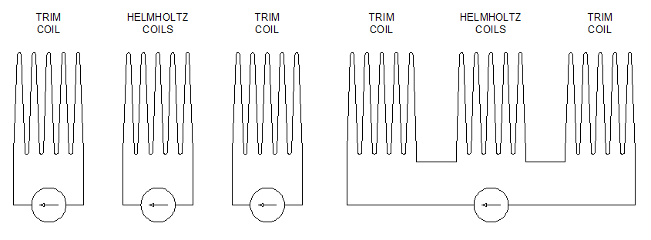
Figure 1. Possible coil connections.

The proposal is to use Anderson SB 175 Connectors for each type of coil. The housing of these connectors is rated to 600V (UL 1977). The contacts used in the housings are rated to 175A (CSA). This system of high power connectors will permit an easily configurable system for making / changing connections to the coils. We propose using 2-postion Anderson connectors at each end of each coil type. A representation of the connection options are depicted in Figure 2.

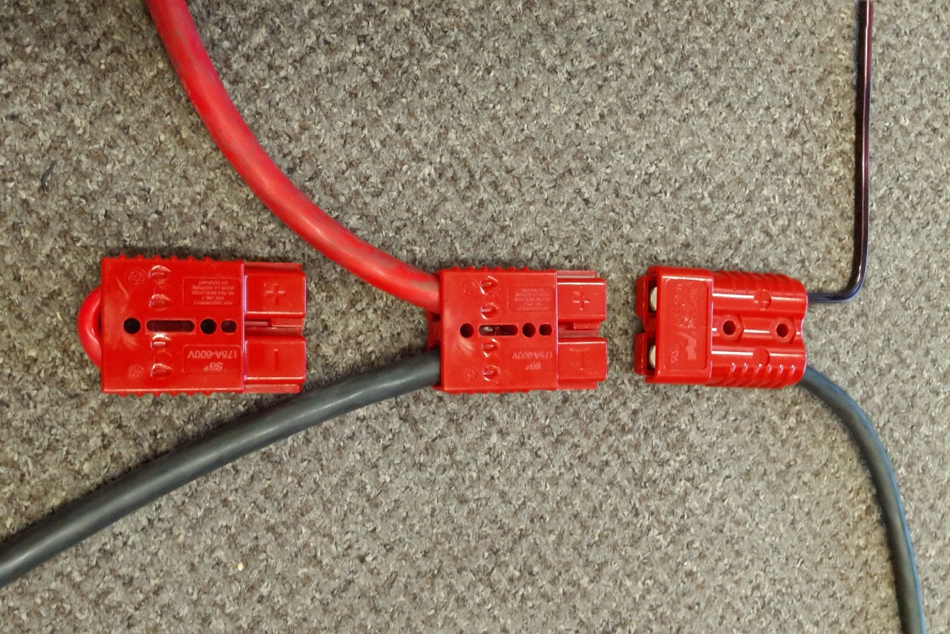
Figure 2. Coil connection proposal.

The 2-position Anderson connector at the right in Figure 2 represents the interface between one end of the series of Helmholtz coils, nominally located toward the top of the figure, and one of the Trim Coils, located toward the bottom. In the instance where the coils are to be energized independently a mating Anderson connector with cables leading to different current sources is used. This is shown in center of Figure 2. When the coils are to be operated in series, the mating 2-position Anderson connector contains a short jumper.

Also shown in Figure 2 is a sample of the 4AWG square magnet wire being considered for the windings of both coil types. This particular wire has a 200C rated polyimide coating and is well matched to the current thoughts about Trim Coil construction. This wire is reasonably stiff, but not completely so. The Anderson connectors are designed to be fastened to a support, which would minimize unnecessary bending of the magnet wire. We are considering methods of rigidly installing the connectors to the outer surface of the vessel.

As shown on the right in Figure 2, we imagine that the connection to the moveable Trim Coil be realized with flexible cable. This short flexible connection would be terminated in a similar Anderson connector attached to the Trim Coil.

