PPD / EED / Infrastructure and Support Group
Technical Note: IG_ 20150002
Michael L. Cherry
Michael S. Matulik
15-Jul-15

Linear Coherent Light Source – II
Vessel Demagnetization
Coil Conductor Proposal

Overview:

Anthony C. Crawford (Fermilab Technical Division) has successfully demonstrated a method of demagnetizing large cylindrical steel vacuum vessels destined to be used for the LCLS-II project at SLAC. Simply stated, a vessel is to be subjected to magnetic fields of reversing direction and diminishing strength. Coils around the vessel carrying current from a programmable current source will provide the magnetic field. It is envisioned that the vessels will be subjected to this demagnetization process as they are received from the vessel vendor, after the associated cryogenic piping and RF Cryo-modules have been installed and perhaps in situ at SLAC.

It is expected that a current waveform (truncated triangular) with a maximum amplitude of 65A will be run through the coils in both directions. The estimated period of this two-direction cycle is 25 to 30 seconds. The amplitude of the current in subsequent cycles will be reduced by some fraction until some terminal current value is reached. The entire process should take about 30 minutes.

Members of the PPD / Electrical Engineering Department have been asked to develop a process of implementing this method to demagnetize a number of vessels. We see this effort broken into the following tasks: Specification of a programmable current source and associated current distribution equipment. Specification of the current carrying conductor(s) that comprise the coils. Working with Technical Division staff to physically realize the coils. Specification of the method of connecting the coils to each other or to current distribution equipment as appropriate. Realizing the system in a safe manor capable of passing installation inspections at SLAC, Fermilab and Jefferson Laboratory (a parallel vessel assembly site).

This note presents a proposal for a means of realizing the coils.

Coil Descriptions:

Two type of coils are required. Regularly spaced Helmholtz coils on the outer surface of the vessel connected in series provide for the demagnetization of most of the vessel. A trim coil at each end of the vessel is used to augment the effect of the Helmholtz coils. The current understanding of the construction of the trim coils is that they are wound into a structure that has an inner diameter larger than the nominal outer diameter of the vessel. This allows them to be moved to accommodate making / breaking the end-flange connections.

Coil Wire Selections:

Trim Coils:

The requirement to realize Trim Coils that are not permanently attached to the vacuum vessel results in the proposal to realize the coil on a circular form / frame with inner diameter greater than the nominal outer diameter of the vacuum vessel. The currently selected frame inner diameter is 1.25m. The estimated number of turns in each Trim Coil is 100.

To facilitate winding the Trim Coils we propose a 4AWG Square Magnet wire.¹ We’ve obtained a sample with a polyimide based insulation rated at 200°C, judged by the manufacturer as adequate for the task. Measurements indicate the outer dimension of the wire is 0.211 inches [5.36mm] on a side. Nominal dimensions for 4AWG square bare wire are 0.2043 inches on a side. Nominal resistance (per 1000 feet at 20°C) is 0.2018Ω. Weight is 0.156 lb/ft.

The cross-section of a frame containing a 10-turn by 10 row array of square wire is shown below.

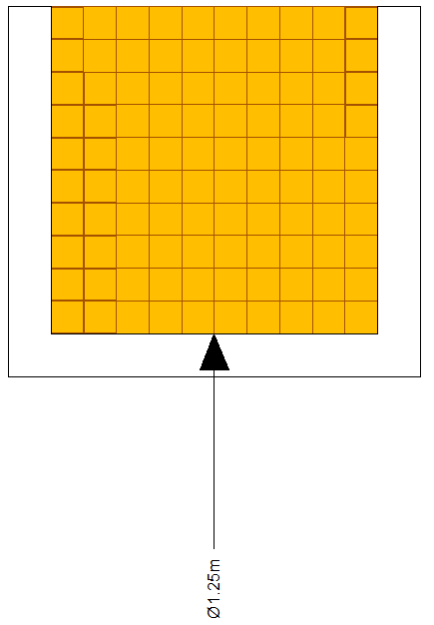
Knowing the starting diameter and the nominal dimension of the wire, we calculate the length of wire required to realize the 100-turn coil to be 401m [1316 ft].

We anticipate terminating both ends of the coil in a common Anderson SB 175 Connector as detailed in Technical Note IG_20150001 “Linear Coherent Light Source – II Vessel Demagnetization Coil Connection Proposal” 1-June-2015. The mating two-terminal connector would have either a pair of connections to an independent power supply, or one connection to the demagnetization power supply and one to the Helmholtz coils on the vacuum vessel.

Aside from the contribution from the frame (not yet determined), the weight of the trim coil is estimated to be 206lb. The resistance of this wire is calculated to be 0.27Ω.

Requests for a quote for two spools of this product and a budgetary quote for production quantities have been generated.

Helmholtz Coil:

Available information indicated that the LCLS-II vacuum vessel is cylindrical with a nominal outer diameter of 1m and a flange-to-flange length of 11.4m. The desired coil winding density is 10 turns per meter, which will be realized with 5-turn (nominal) coils placed along the length of the vessel every 0.5m.

Assuming that the first and last sections of the Helmholtz Coil are not located under the Trim Coils, there would be 21 5-turn coils required to cover the vessel length between. Accounting for the pitch (p) of the 5-turn coils one can calculate the length of wire required to realize the Helmholtz Coil to be around a 1m (Φ):

$$l=21(5)π∅+20p$$
$$l=340m \left[1115ft\right]$$

If 5-turn coils are required under the Trim Coils the length of wire would increase to 372m [1221ft].

The rigidity of the square magnet wire proposed for the trim coils is a disadvantage when considering using it on the vessel as the numerous obstructions (primarily ports) on the outer surface of the vacuum vessel will require significant deviations in the routing. Instead we are proposing 6AWG stranded wire. We’ve found several sources of 19 x 0.372, 90°C and105°C, 600V building wire. We are in the process of determining material requirements for installation / possible operation at SLAC. Results of this effort may dictate the selection of wire with a different insulation. Though stranded, this wire is not extremely flexible. We plan to take advantage of this aspect to help keep the shape of the coils when wound on the vacuum vessel.

Each of the two ends of the wound Helmholtz Coil would be terminated into an independent Anderson SB 175 Connector. A cable to the demagnetization power supply, or a short jumper to the neighboring Trim Coil will be fitted into the mating connector as appropriate.

Data for this type of wire indicates a nominal resistance of 0.45Ω/1000ft and weight of 94 lb/1000ft. Using these values we estimate the resistance of the wire to be 0.5Ω for the 21 5-turn coil solution and 0.55Ω for the longer one. Corresponding weights would be 105lb and 115lb respectively (not including the weight of the spool).

Winding the Trim Coils:

It is anticipated that the design of the trim coil frame and an appropriate manner to wind the coils will be primarily carried out by members of the Technical Division.

Winding the Helmholtz Coil:

We suggest single spools of sufficient length to realize all of the required 5-turn coils to avoid splices. We imagine paying off the wire from a spool onto a rotating vessel would be preferred to passing the full weight spool over and under a stationary one. We will be consulting with members of the Technical Division to determine the feasibility of rotating the vacuum vessel.

- MWS Wire Industries 4 SQ HAPT NEMA MW36-C

