PPD / EED / Infrastructure and Support Group
Technical Note: IG_ 20150004
Michael S. Matulik
17-Jul-15

Job Hazard Analysis
Removing Beryllium Oxide Heat Spreaders
From D0 BLS Style Power Supply
Aluminum Cooling Plate Assemblies

Overview:

Fermilab designed and assembled power supplies used for D0 Calorimeter Base Line Subtractor (and similar) crates utilize beryllium oxide heat spreaders to move waste heat from power transistors to water-cooled aluminum cooling plate assemblies. The beryllium oxide heat spreaders need to be removed from the assemblies and stored separately for proper disposal. The cooling plate assemblies have been previously removed from the power supply chassis.

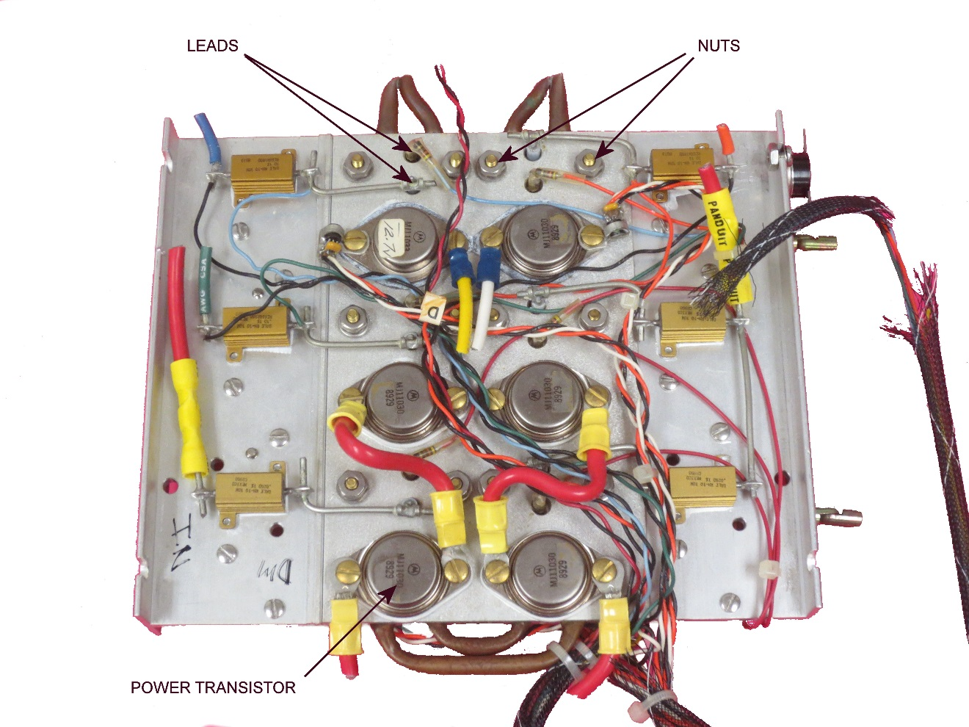
Figure 1. One side of aluminum cooling plate assembly.
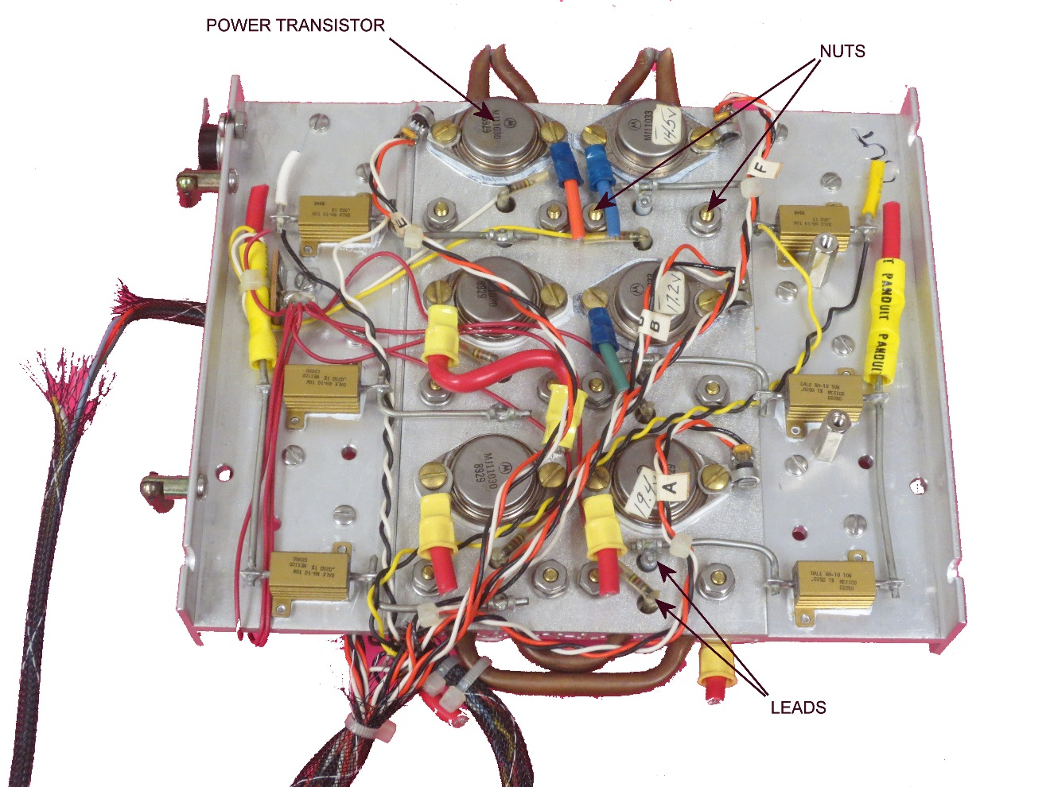
Figure 2. Opposite side of aluminum cooling plate assembly.

The two sides of an aluminum cooling plate assembly are depicted in Figures 1 and 2. As shown, there are a total of 12 power transistors mounted to the cooling plate. Heat spreaders are located between a transistor and the cooling plate. Transistors are held to the heat spreader with two screw and nut assemblies. The two leads of the transistor are soldered to wires or components as necessary to realize electrical connections.

Not all power transistors found on a given cooling plate require a beryllium heat spreader. The thicker white heat spreaders are beryllium oxide. The thinner silver / grey heat spreaders are anodized aluminum and do not need to be removed.

Required Training:

Beryllium Handling [FN000196/CR]

Additional Protective Equipment:

Polyethylene plastic sheeting (Visqueen) to avoid contamination of the work surface.

Potential Hazards:

- Removal of the beryllium heat spreader should not cause it to fracture, but some were fractured during assembly. If the removal process is found to cause these heat spreaders to fracture, STOP the work for additional review.
- As these power supplies have been installed in the D0 Collision Hall, the waste (the remainder of the cooling plate assembly) is considered Group 2 and needs to be identified as such.

Work to be performed:

Note that this procedure only needs to be performed to remove the beryllium oxide heat spreaders, the aluminum heat spreaders can be left installed. Wires and / or components found to be interfering with the removal process can be cut away and placed in an appropriate Group 2 Waste container

- Apply the tip of a large soldering iron to the junction of a transistor lead and associated wire / component. Grip the wire / component with the needle-nose pliers and pull gently to disconnect.
- Use a flat blade screwdriver and appropriate pliers or nut driver to remove the screws. The nuts and screws should be placed in a Group 2 Metallic Waste container.
- A thin layer of thermal grease will be found between the transistor and the heat spreader and the heat spreader and the aluminum plate. This white compound is quite tacky and difficult to remove from clothing. Gently remove the transistor, taking care not to fracture the heat spreader. The transistor should be placed in a Group 2 Electronic Waste container.
- Gently remove the beryllium oxide heat spreader and store in a plastic sealable bag labeled “Beryllium”. The individual pieces of heat spreaders found to be fractured should be collected (perhaps with tweezers) and stored in the same plastic bag. The beryllium oxide heat spreaders from many cooling plates can stored in the same plastic bag.
- When all of the beryllium oxide heat spreaders are removed from a cooling plate, the cooling plate should be placed in a Group 2 Electronic Waste container.

