PPD / EED / Infrastructure and Support Group
Technical Note: IG_ 20160005
Michael L. Cherry
Michael S. Matulik
3-Mar-16

Rack Protection and Current Interruption for
ANNIE Racks in the SciBooNE Experimental Hall

Overview:

The ANNIE Experiment will soon be operating racks containing various crates of electronics in the experimental hall that once housed the SciBooNE Experiment. This note describes equipment used to provide Rack Protection / Power Interruption capabilities for these racks.

DZero Rack Monitor Interface Chassis:

The heart of the Rack Protection / Current Interruption system is the re-purposed DZero Rack Monitor Interface Chassis. For this application the 2U high device interfaces with a photo-electric smoke detector and provides an interlock signal (indicating when it is safe / unsafe to pass AC current) to current interruption devices in series with AC power connections into a rack. A copy of the DZero Rack Monitor Interface Chassis Specification has been included in the Appendix.

For this application, the Rack Monitor Interface is set up to only monitor the status of the smoke detector unit.

Basic Operation:

Particulate in the air passes through the sensing region of the smoke detector. Light reflecting from the particulate is captured by a photodetector. The output of the photodetector is proportional to the amount of particulate. Sufficient particulate in the monitoring region will result in a trip condition. Circuitry found in the smoke detector base monitors the operation of the smoke detector and latches the trip condition. The trip status is relayed to the Rack Monitor Interface via the 4-conductor cable. Internally, the Rack Monitor Interface also latches the tripped state of the smoke detector. The front panel LED for “Smoke Detector” changes color from green to red. If the annunciator switch is in the “Enable” position, the Rack Monitor Interface also emits an audible alarm. Further, if the Rack Monitor Interface does not sense that a smoke detector is connected, either by disconnected cable or remove smoke detector head, the unit will indicate a “Smoke Detector” trip and inhibit the interlock signal.

Pressing the “Reset Alarms” momentary switch on the front panel of the Rack Monitor Interface does two things; interrupts the power delivered to the smoke detector, which is the method by which it is reset, and clears the internally latched trip condition(s). Once particulate has cleared from the smoke detector and no longer sends a tripped indication, the Rack Monitor Interface will silence the audible alarm and change the front panel LED back to green.

Pulizzi Power Controller:

Commercial Pulizzi Power Controllers (model 1294) have also been repurposed from the D0 Experiment. These 1U high devices contain four interlock enabled NEAM 5-15 duplex receptacles. Each set of two receptacles is in series with a 15A front panel mounted circuit breaker. An internal relay is in series with the non-grounded connection to the receptacles. To operate properly, the Rack Monitor Interface requires a non-interlocked source of AC power. We’ve modified the Pulizzi Power Controller to provide the non-interlocked power by disconnecting one pair of receptacles from the contacts of the internal relay and connecting them directly to the output of one of the circuit breakers. Labelling applied to the chassis indicates the location of the two non-interlocked receptacles. The remaining two receptacles are available for interrupting power to ANNIE Experiment electronics crates, subject to a maximum total current of less than 15A. The plug end of the power cord to this device was re-terminated to match the twist-lock receptacles located in the SciBooNE Experimental Hall.

The interlock function of this device is controlled by an external normally closed contact. A RG-58 coaxial cable is terminated with the proper 4-contact Molex connector to mate with the front panel header is provided. The other end of the cable will be connected to the BNC connector labeled “Blower Interlock Normally Closed Contact” on the rear panel of the Rack Monitor Interface. Figure 1 indicates the position of this BNC connector.

Bira Systems Model 8885 Interlocked AC Outlet:

The Bira Interlocked AC Outlet is a commercial device consisting of a NEMA 5-20 duplex receptacle and an internal Crydom D2425 25A solid state relay. The plug end of the power cord to this device was re-terminated to match the twist-lock receptacles located in the SciBooNE Experimental Hall. Two Bira Outlets are provided for each ANNIE rack.

The interlock function of this device is controlled by an applied dc voltage in the range 3 – 32V. A standard BNC terminated RG58 coaxial cable is provided to connect the interlock BNC on the Bira Outlet to the BNC connector labeled “Blower Interlock Normally TTL High” on the rear panel of the Rack Monitor Interface. Figure 1 indicates the position of this BNC connector.

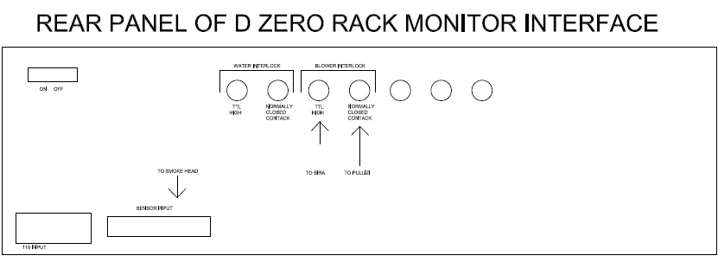
Figure 1. Cable connections

Appendix:

“DZERO Rack Monitor Interface Chassis Specification”. Revision date; 1/30/91.

