PPD / EED / Infrastructure and Support Group
Technical Note: IG_ 20160009
Michael L. Cherry
Michael S. Matulik
1-Jun-16

Linear Coherent Light Source – II
Vessel Demagnetization
Programmable Current Source /
Current Distribution System
Magna-Power Initialization Sequence

Overview:

The source of current for demagnetizing LCLS-II vacuum vessels is a commercial power supply manufactured by Magna-Power. The XR80-75/208 power supply can be configured to operate in several modes. After providing instructions for connecting the power supply to AC power, this document provides instructions for setting up the supply to operate properly as a current source in this effort.

Connecting to AC Power:

Refer to Fermilab TD/SRFD document ED0005095 for information detailing the connection of the Magna-Power supply to AC power.

Desired Configuration:

Prior to operating the LabVIEW program that provides the external current reference voltage to the power supply the Magna-Power needs to be configured to be in both Internal Control and External Programming modes. The front panel display should look like the supply pictured in Figure 1.

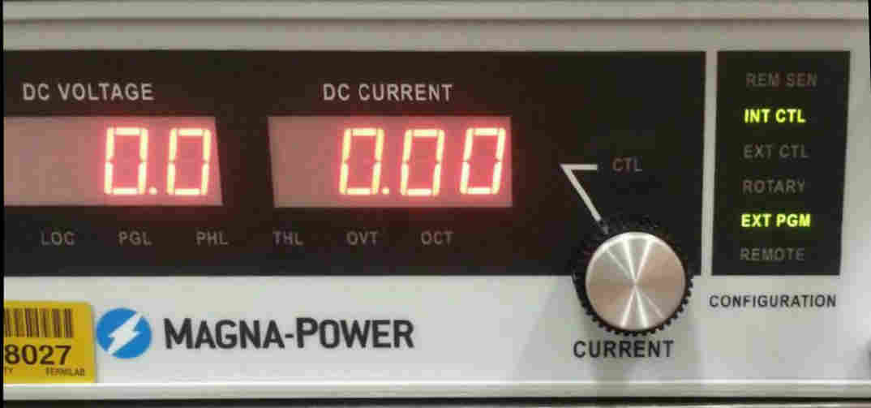
Figure 1. Magna-Power indicating Internal Control, External Programming modes.

Changing Magna-Power Configuration:

If the front panel display does not match the picture in Figure 2 the Magna-Power needs to be reconfigured. There is an array of function keys on the front panel, above the green “START” and red “STOP” buttons. Changing the configuration involves pressing a sub-set of these buttons in a specific sequence. Note the CTL LED above the CURRENT potentiometer may or may not be illuminated.

For LCLS-II efforts the power supply has 6 possible operating modes which correspond to the indications in the “CONFIGURATION” field on front panel of the supply.

- REM SEN: When illuminated indicates that the supply expects that voltage sense leads are connected to the load to compensate for voltage drop over the cables connecting the supply to the load. For vessel demagnetization we operate the supply as a current source. The voltage drop across the cables to the vessel are of no consequence.
- INT CTL: When illuminated indicates that the supply can be started and stopped by pressing the START and STOP buttons.
- EXT CTL: When illuminated indicates that the supply can be started and stopped by external means. The front panel START and STOP buttons are disabled.
- ROTARY: When illuminated indicates that the voltage and current set points are established by operating the two front-panel rotary potentiometers.
- EXT PGM: When illuminated indicates that the voltage and current set points are established by voltages on a 37-pin rear-panel dSub connector.
  - Note that the two previous modes of operation appear to be mutually exclusive – enabling one mode disables the other.
- REMOTE: When illuminated indicates that the power supply will be controlled by a computer (via RS232 or other optional communication protocols).

The procedure for changing which indicator is illuminates follows a logical path. The Magna-Power front function keys involved in changing the operating mode are shown in Figure 2.

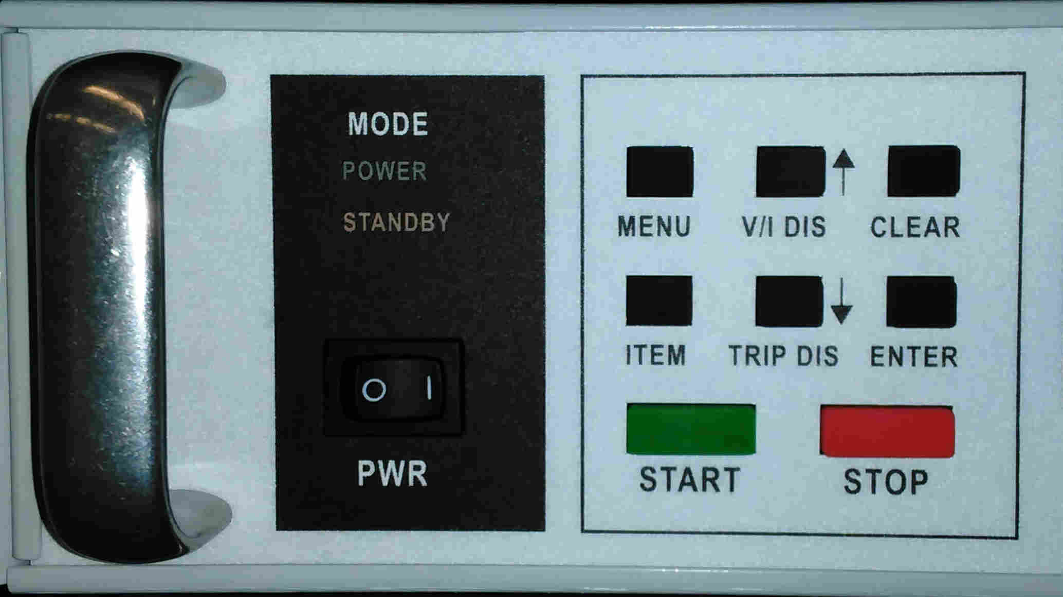
Figure 2. Magna-Power function keys.

- Operate the PWR rocker switch to apply power the supply. The changing front panel display indicates the supply is performing diagnostic tests. The STANDBY indication will be illuminated.
- The first step in changing the operating mode of the supply is to press the MENU button. The supply responds by displaying some mode of operation. Note that this display will involve a flashing indication in the OVT (over voltage trip), OCT (over current trip) of DC VOLTAGE sections of the front panel.
- Pressing the ITEM button repeatedly will scroll through the operating modes (flashing indication) that are available to be selected. For use in LCLS-II demagnetization, keep pressing the ITEM key until the DC VOLTAGE display reads “conF”.
- Pressing the ENTER button while the desired configuration operating mode indication is flashing (“conF”) provides access to a sub-set of operating modes, indicated by a flashing indication in the CONFIGURATION field on the front panel.
  - Repeatedly pressing the ITEM button will scroll through the sub-set of operating modes (flashing indication) that are available to be selected.
  - Pressing the ENTER button while the desired operating mode is flashing will enable that mode.
  - Pressing the CLEAR button while the desired operating mode is flashing will disable that mode.
  - Pressing ENTER or CLEAR will affect the supply appropriately and the supply will return to STANDBY. Further changes are made following the same procedure.

