PPD / EED / Infrastructure and Support Group
Technical Note: IG_ 20170004
Michael S. Matulik
12-May-17

HL-LHC Outer Tracker
Baseplate Heater
Circuit Description

Overview:

A two-layer flexible printed circuit in the shape of the HL-LHC Outer Tracker Baseplate is being designed to dissipate power in the form of heat in 7 sections to verify operation of cooling systems. The desired dissipated power for each section has been provided by HL-LHC Outer Tracker collaborators. This note describes the proposed circuit.

Circuit Description:

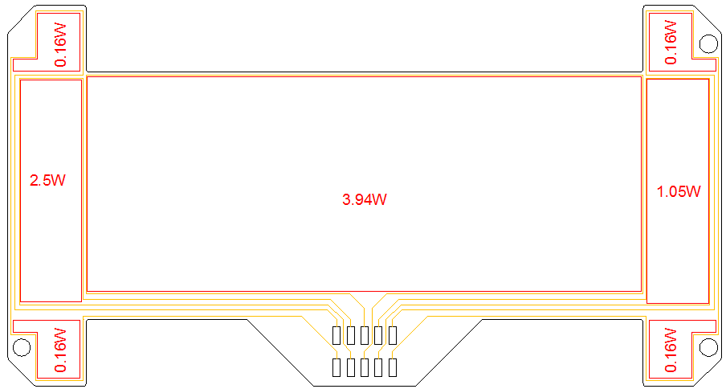
Figure 1 Baseplate Heater Circuit.

The 7 sections of the circuit are indicated in red, along with the desired dissipated power. For each section, the thickness, width and length of a bottom copper layer trace will determine the resistance in accordance with $R= ρl/tw$. Applying a dc potential across this trace will generate power in accordance with $P=V^{2}/R$. Copper thickness for the layer must be common to all sections, so the factors that can be varied to obtain the desired power values are applied voltage, trace width and trace length.

Just less than half of the area in each section is assumed to be available for routing traces. To maintain manufacturability, the width of the trace and the distance between spaces will be equal and at least 80µm. Knowing the area available for traces one can vary the width of the trace to determine the length of the trace in each section, and thus the trace resistance. Varying the applied potential yields the dissipated power.

With the exception of the four corner sections, the current path to / from each section is distinct. The two corner sections on the left side of the circuit and the two corner sections on the right are each routed in parallel yielding 5 sections that can be independently controlled for power dissipation. An upper copper layer surface mount 10-contact, 2-row pin header is provided to make connections to the circuits.

While every effort was made to generate trace geometries in each section that would permit the same potential to be applied to all sections simultaneously, the significant difference in desired dissipated power doesn’t allow this.

With the help of an Excel spreadsheet to keep track of all the variables the proposed circuit layout consists of:

- 50µm thick base polymide with 9µm thick copper on both sides. Note the availability of this material has been confirmed with at least one circuit fabricator.
- Solder mask or polyimide cover coat system on both sides. Working with the circuit fabricator, the thinner option will be selected.
- A nominal potential of 6Vdc will be applied to each circuit, unless otherwise noted.
  - With the 2 two-corner circuits wired in parallel (wiring external to 10-pin strip header), the trace width in each corner will be 90µm. The overall trace length will be 62.7cm in each corner. The expected resistance of this trace is 13.2Ω. Desired dissipated power is 0.16W in each corner. Expected dissipated power is 0.17W. Current though this circuit will be 0.11A.
    - With each two-corner section powered independently the same dissipated power can be expected if the voltage applied to each circuit is 3Vdc.
  - The expected dissipated power in the left-most section is 2.5W. The trace width will be 190µm. The overall trace length will be 147.3cm. The expected resistance of this trace is 14.6Ω. Expected dissipated power is 2.46W. Current through this circuit will be 0.41A.
  - The expected dissipated power in the center section is 3.94W. The trace width will be 650µm. The overall trace length will be 312.8cm. The expected resistance of this trace is 9.1Ω. Expected dissipated power is 3.96W. Current through this circuit will be 0.66A.
  - The expected dissipated power in the right-most section is 1.05W. The trace width will be 130µm. The overall trace length will be 215.3cm. The expected resistance of this trace is 31.3Ω. Expected dissipated power is 1.15W. Current through this circuit will be 0.19A.

An option to be able to split the circuit in half along the long axis and add upper copper layer solder jumpers to complete each circuit is being considered. If this option is desired, the trace widths in the three middle sections changes slightly, but the expected dissipated power are about the same for 6Vdc.

